YEAR 12 CRIMINOLOGY TRANSITION PROJECT
Task 1: Serial Killer fact file
- Choose a serial killer (s) either from the list below or of your own choice:
Ian Brady and Myra Hindley
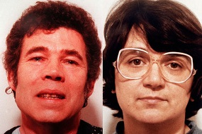Fred and Rose West
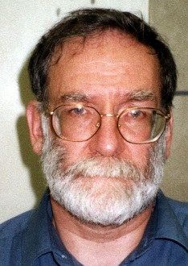Harold Shipman Joanne Dennehey
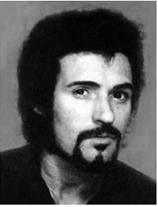Peter Sutcliffe (The Yorkshire ripper)
- Write a fact file which should include the following information:

- Their crimes and victims
- Details of their trial
- Details of their sentence
- Information about their background which might explain their criminal behaviour such as head injuries, mental illness, childhood abuse

Task 2: All about hate crime
- Since the public vote on BREXIT there has been a marked increase in this type of crime. Using the sources below and any others you feel are appropriate answer the questions below:
http://www.independent.co.uk/news/uk/crime/brexit-hate-crime-racism-stats-spike-police-england-wales-eu-referendum-a7126706.html
https://www.victimsupport.org.uk/crime-info/types-crime/hate-crime
http://www.stophateuk.org/
http://www.lgbthatecrime.org.uk/
- What is hate crime?
- Who are the potential victims?
- Find two examples of real victims of hate crime and write a summary of each case
- Find 2 examples of support groups who help victims of hate crime and outline their aims and objectives
- Watch the following documentary on you tube (bbc3 the ugly face of disability – hatecrime)
https://www.youtube.com/watch?v=B03jduD9N5o&safe=active

